**CSC500 Module 6 Portfolio Milestone**

Crystal Davis

9/21/2025

**SOURCE CODE (INCLUDING MOD 4 SOURCE CODE):**

**MOD 4:**

# ItemToPurchase class

class ItemToPurchase:

    def __init__(self, name="none", description="none", price=0, quantity=0):

        self.item_name = name

        self.item_description = description

        self.item_price = price

        self.item_quantity = quantity

    def print_item_cost(self):

        total = self.item_price * self.item_quantity

        print(f"{self.item_name} {self.item_quantity} @ ${self.item_price:.2f} = ${total:.2f}")

    def print_item_description(self):

        print(f"{self.item_name}: {self.item_description}")

**MOD 6 SOURCE CODE:**

# ShoppingCart class

class ShoppingCart:

    def __init__(self, customer_name="none", current_date="January 1, 2020"):

        self.customer_name = customer_name

        self.current_date = current_date

        self.cart_items = []

    def add_item(self, item):

        self.cart_items.append(item)

    def remove_item(self, item_name):

        found = False

        for item in self.cart_items:

            if item.item_name == item_name:

                self.cart_items.remove(item)

                found = True

                break

        if not found:

            print("Item not found in cart. Nothing removed.")

    def modify_item(self, item):

        found = False

        for cart_item in self.cart_items:

            if cart_item.item_name == item.item_name:

                if item.item_description != "none":

                    cart_item.item_description = item.item_description

                if item.item_price != 0:

                    cart_item.item_price = item.item_price

                if item.item_quantity != 0:

                    cart_item.item_quantity = item.item_quantity

                found = True

                break

        if not found:

            print("Item not found in cart. Nothing modified.")

    def get_num_items_in_cart(self):

        total_quantity = 0

        for item in self.cart_items:

            total_quantity += item.item_quantity

        return total_quantity

    def get_cost_of_cart(self):

        total_cost = 0

        for item in self.cart_items:

            total_cost += item.item_price * item.item_quantity

        return total_cost

    def print_total(self):

        print(f"{self.customer_name}'s Shopping Cart - {self.current_date}")

        total_items = self.get_num_items_in_cart()

        print(f"Number of Items: {total_items}")

        if total_items == 0:

            print("SHOPPING CART IS EMPTY")

        else:

            for item in self.cart_items:

                item.print_item_cost()

        print(f"\nTotal: ${self.get_cost_of_cart():.2f}")

    def print_descriptions(self):

        print(f"{self.customer_name}'s Shopping Cart - {self.current_date}")

        print("Item Descriptions")

        for item in self.cart_items:

            item.print_item_description()

# Menu function

def print_menu(cart):

    choice = ""

    while choice != "q":

        print("\nMENU")

        print("a - Add item to cart")

        print("r - Remove item from cart")

        print("c - Change item quantity")

        print("i - Output items' descriptions")

        print("o - Output shopping cart")

        print("q - Quit")

        choice = input("Choose an option:\n")

        if choice == "a":

            print("\nADD ITEM TO CART")

            name = input("Enter the item name:\n")

            description = input("Enter the item description:\n")

            price = float(input("Enter the item price:\n"))

            quantity = int(input("Enter the item quantity:\n"))

            item = ItemToPurchase(name, description, price, quantity)

            cart.add_item(item)

        elif choice == "r":

            print("\nREMOVE ITEM FROM CART")

            name = input("Enter name of item to remove:\n")

            cart.remove_item(name)

        elif choice == "c":

            print("\nCHANGE ITEM QUANTITY")

            name = input("Enter the item name:\n")

            quantity = int(input("Enter the new quantity:\n"))

            item = ItemToPurchase(name=name, quantity=quantity)

            cart.modify_item(item)

        elif choice == "i":

            print("\nOUTPUT ITEMS' DESCRIPTIONS")

            cart.print_descriptions()

        elif choice == "o":

            print("\nOUTPUT SHOPPING CART")

            cart.print_total()

        elif choice == "q":

            break

        else:

            print("Invalid option. Please try again.")

# Main function

def main():

    customer_name = input("Enter customer's name:\n")

    current_date = input("Enter today's date:\n")

    print(f"\nCustomer name: {customer_name}")

    print(f"Today's date: {current_date}")

    cart = ShoppingCart(customer_name, current_date)

    print_menu(cart)

# Start program

main()

**SCREENSHOTS:**

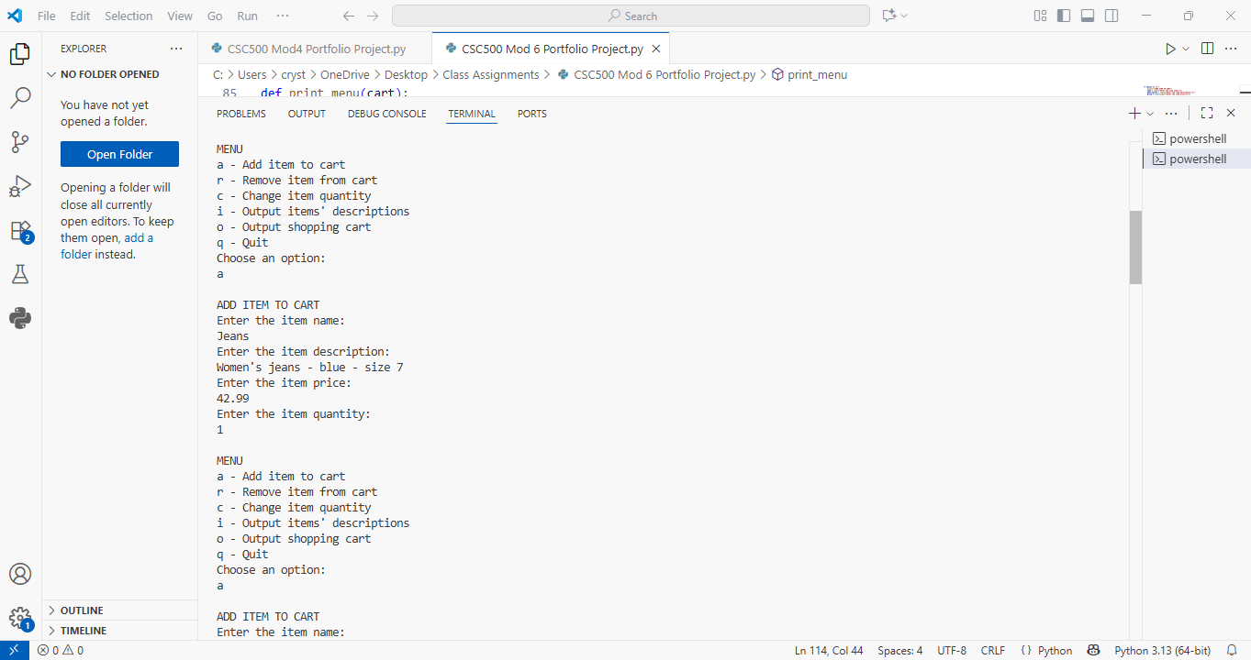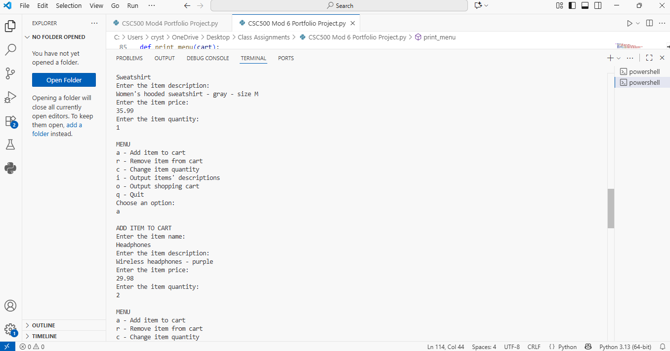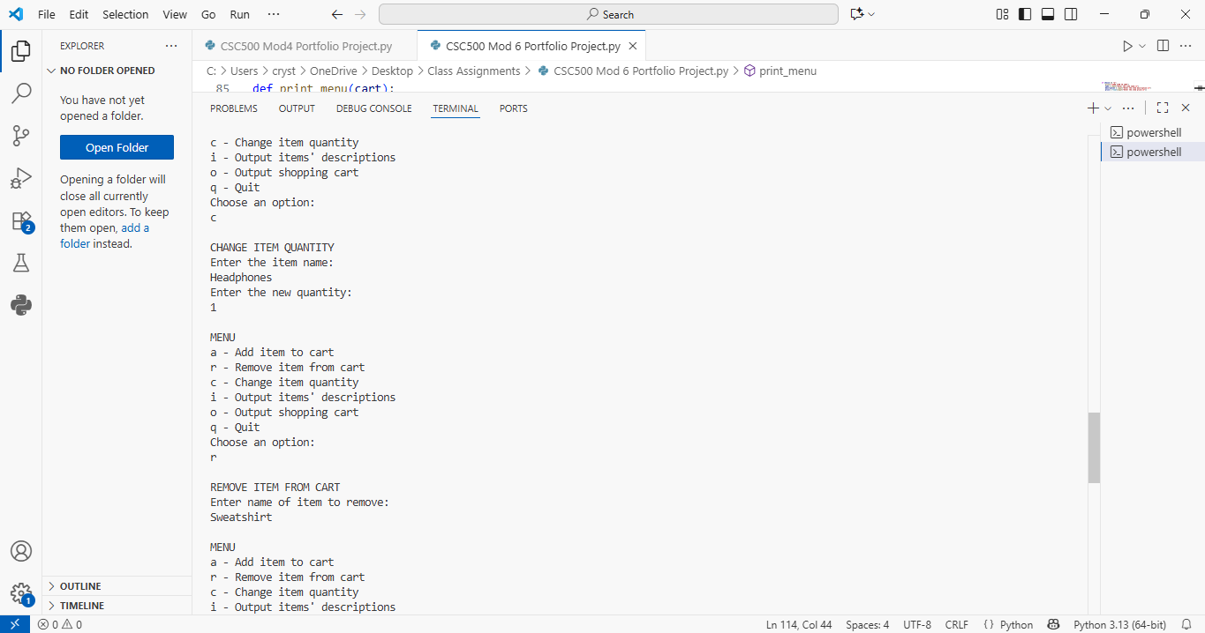

**GITHUB REPOSITORY:**

<https://github.com/kaufmancl1/CSC500-Mod6-Portfolio-Project>